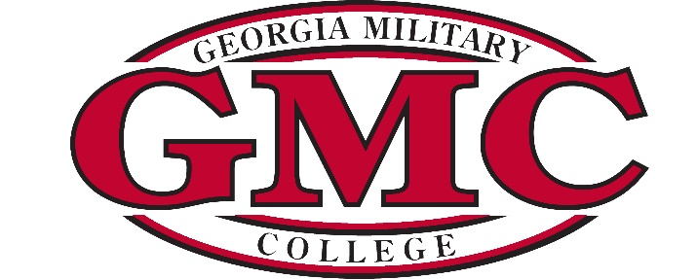

Georgia Military College
Board of Trustees

2024
Meeting Schedule and Agenda Items

Standard Items for Every Meeting

Approval of Minutes Finance Committee Report
Chairman’s Report President’s Report
Engineering Update

January 18, 2024  8:00 AM | CALLED MEETING
March 19, 2024  4:00 PM | Annual Agenda Items:  Foundation Report  Alumni Association Report  Conflict of Interest & Undue Influence Training
June 14, 2024  1:00 PM | Annual Agenda Items:  Budget Approval  Junior College Update
September 17, 2024  4:00 PM | Annual Agenda Items:  Prep School Update  President’s Annual Evaluation
December 3, 2024  4:00 PM | Annual Agenda Items:  Global Online Leadership College Update

